Challenge on Terraform

Write a code using Terraform that deploys and achieves the following:-

1. Create an EC2 Instance on AWS Cloud using the below-mentioned ubuntu AMI and instance_type. Or, (You can use of your choice as well) ami = "ami-0461b1436c9b3c1a3" instance_type = "t2.micro"

Templates used to execute the challenge. Used ami and instance type of my choice.

Main.tf:
provider "aws" {
region = var.aws_region
}

# EC2 Instance
resource "aws_instance" "cb_server" {
ami = var.ami_id
instance_type = var.instance_type
key_name = var.key_name
associate_public_ip_address = true
vpc_security_group_ids = [var.security_group_id]
user_data = file("setup.sh")

tags = {
Name = "CricbuzzDockerServer"
Environment = "Terraform-Challenge"
Owner = "Mubeen"
Project = "Docker-Cricbuzz-App"
ManagedBy = "Terraform"
}
}

output "terraform-challenge" {
description = "Public IP for accessing the Cricbuzz App"
value = aws_instance.cb_server.public_ip
}

Varibales.tf;
variable "aws_region" {
description = "AWS region to deploy resources"
default = "us-east-1"
}

variable "ami_id" {
description = "AMI ID for Ubuntu 24.04 in Virginia region"
default = "ami-020cba7c55df1f615"
}

variable "instance_type" {
description = "EC2 instance type"
default = "t2.micro"
}

variable "key_name" {
description = "Name of the existing key pair"
default = "Virginia"
}

variable "security_group_id" {
description = "Security group ID to allow traffic"
default = "sg-05a7015767640bf35"
}

Setup.sh:
#!/bin/bash

set -e

echo "---------------- Updating system and installing packages ----------------"
sudo apt update -y
sudo apt install -y git docker.io docker-compose nginx

echo "---------------- Starting and enabling Docker ----------------"
sudo systemctl start docker
sudo systemctl enable docker
sudo usermod -aG docker ubuntu

echo "---------------- Cloning Docker App ----------------"
sudo rm -rf /opt/cricbuzz
sudo git clone https://github.com/betawins/cricbuzz-docker-hello-world.git /opt/cricbuzz
cd /opt/cricbuzz

echo "---------------- Overwriting Go Application Output Message ----------------"
cat <<'EOF' | sudo tee /opt/cricbuzz/hello_world.go > /dev/null
package main

import (
"fmt"
"net/http"
)

func handler(w http.ResponseWriter, r *http.Request) {
fmt.Fprintln(w, "Hello, Cricbuzz Docker World!")
}

func main() {
http.HandleFunc("/", handler)
http.ListenAndServe(":8000", nil)
}
EOF

echo "---------------- Creating Dockerfile (Multi-stage Build) ----------------"
cat <<'EOF' | sudo tee Dockerfile > /dev/null
# Stage 1: Build Go app
FROM golang:1.22-alpine AS builder
WORKDIR /app
COPY go.mod .
COPY go.sum .
RUN go mod download
COPY . .
RUN CGO_ENABLED=0 GOOS=linux go build -a -installsuffix nocgo -o hello_world ./hello_world.go

# Stage 2: Final minimal image
FROM ghcr.io/vincetse/scratch
COPY --from=builder /app/hello_world .
ENV GIN_MODE release
EXPOSE 8000
ENTRYPOINT ["/hello_world"]
EOF

echo "---------------- Building and Running Docker Container ----------------"
sudo docker stop cricbuzz || true
sudo docker rm cricbuzz || true
sudo docker rmi cricbuzz-local || true
sudo docker build -t cricbuzz-local .
sudo docker run -d --name cricbuzz -p 8000:8000 -e PORT=8000 cricbuzz-local

echo "---------------- Configuring Nginx Reverse Proxy (8080 -> 8000) ----------------"
cat <<'EOF' | sudo tee /etc/nginx/sites-available/cricbuzz > /dev/null
server {
listen 8080;
location / {
proxy_pass http://localhost:8000;
proxy_set_header Host $host;
proxy_set_header X-Real-IP $remote_addr;
proxy_set_header X-Forwarded-For $proxy_add_x_forwarded_for;
proxy_set_header X-Forwarded-Proto $scheme;
}
}
EOF

sudo ln -sf /etc/nginx/sites-available/cricbuzz /etc/nginx/sites-enabled/cricbuzz
sudo rm -f /etc/nginx/sites-enabled/default
sudo nginx -t && sudo systemctl reload nginx

echo "---------------- Creating Custom Log File and Logrotate Setup ----------------"
sudo touch /var/log/cb.log
sudo chmod 666 /var/log/cb.log

cat <<'EOF' | sudo tee /etc/logrotate.d/cb > /dev/null
/var/log/cb.log {
daily
rotate 7
compress
missingok
notifempty
create 0644 root root
}
EOF

echo "---------------- Setup Completed Successfully ----------------"

We need to run commands terraform init and terraform apply.

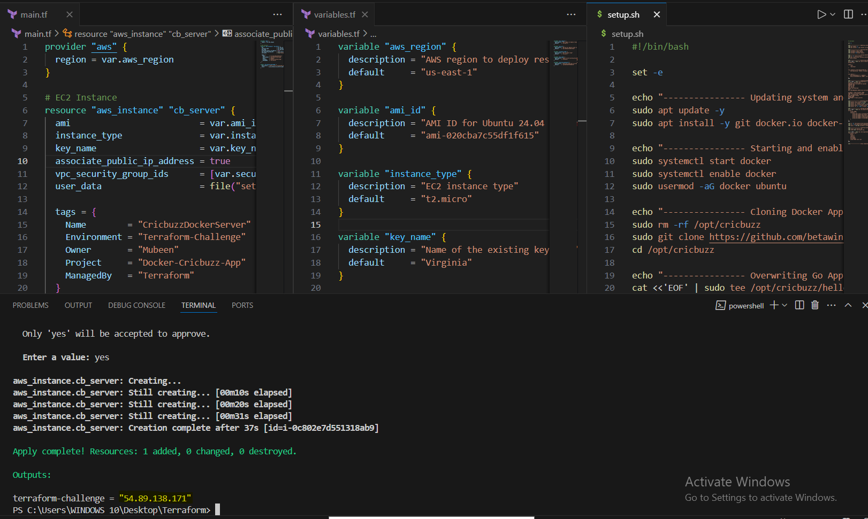
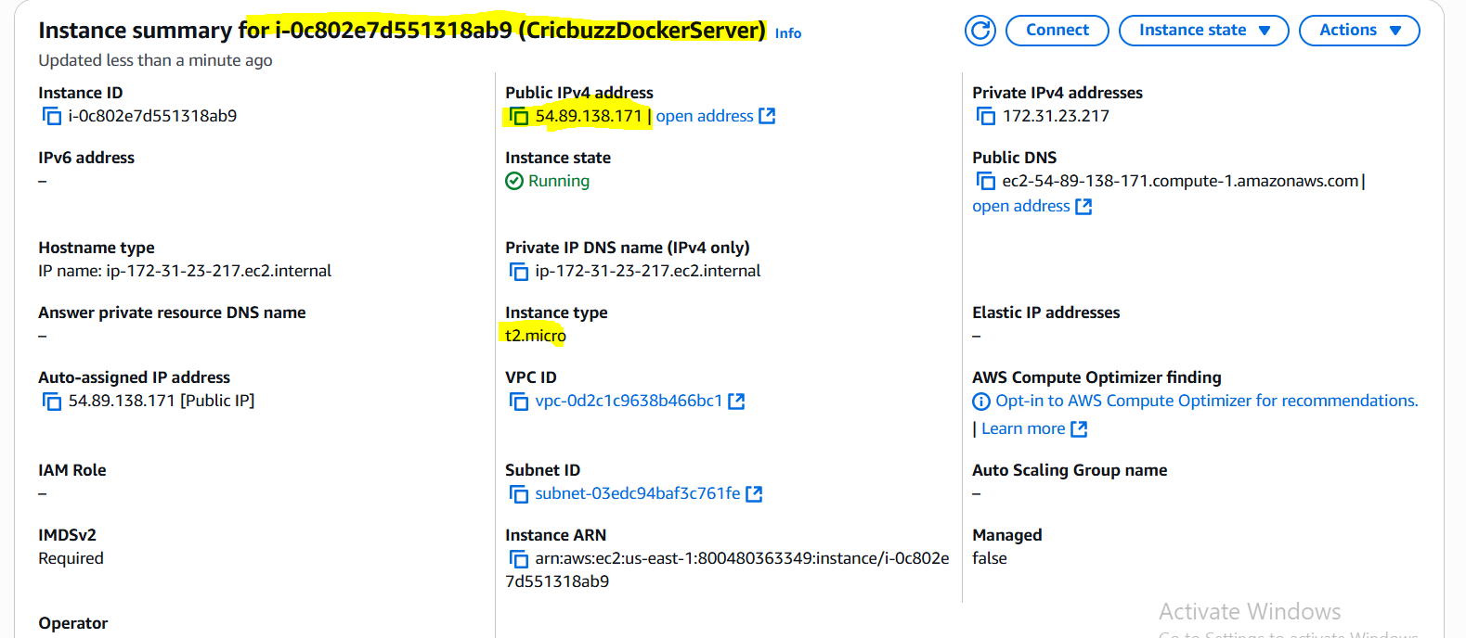
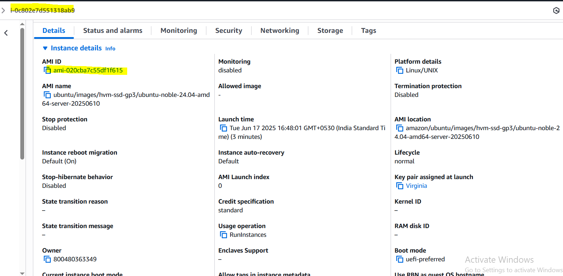

2. Install a web server on the same EC2 Instance. The web server should listen on port 8080.

Install a Web Server on the same EC2 Instance (listening on port 8080)
Relevant Lines:
sudo apt install -y git docker.io docker-compose nginx
sudo systemctl start docker
sudo systemctl enable docker
sudo usermod -aG docker ubuntu

cat <<'EOF' | sudo tee /etc/nginx/sites-available/cricbuzz > /dev/null
server {
listen 8080;
location / {
proxy_pass http://localhost:8000;
proxy_set_header Host $host;
proxy_set_header X-Real-IP $remote_addr;
proxy_set_header X-Forwarded-For $proxy_add_x_forwarded_for;
proxy_set_header X-Forwarded-Proto $scheme;
}
}
EOF

sudo ln -sf /etc/nginx/sites-available/cricbuzz /etc/nginx/sites-enabled/cricbuzz
sudo rm -f /etc/nginx/sites-enabled/default
sudo nginx -t && sudo systemctl reload nginx
This installs Nginx and configures it to reverse proxy from port 8080 ➝ 8000.
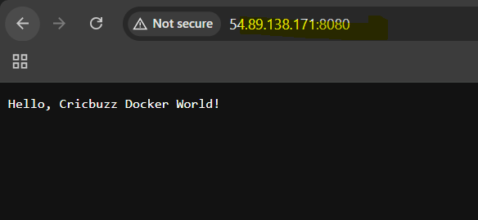

3. Create a Docker-compose file for the project: https://github.com/betawins/cricbuzz-docker-hello-world.git and point it to port 8000.

Create a Dockerfile (port 8000) for cricbuzz-docker-hello-world
Relevant Lines:
sudo git clone https://github.com/betawins/cricbuzz-docker-hello-world.git /opt/cricbuzz
cd /opt/cricbuzz
This clones the repository.
# Overwrite hello_world.go to produce correct output
cat <<'EOF' | sudo tee /opt/cricbuzz/hello_world.go > /dev/null
package main

import (
"fmt"
"net/http"
)

func handler(w http.ResponseWriter, r *http.Request) {
fmt.Fprintln(w, "Hello, Cricbuzz Docker World!")
}

func main() {
http.HandleFunc("/", handler)
http.ListenAndServe(":8000", nil)
}
EOF
Replaces the default Go code to return the correct response: Hello, Cricbuzz Docker World!
cat <<'EOF' | sudo tee Dockerfile > /dev/null
# Multi-stage Dockerfile
FROM golang:1.22-alpine AS builder
WORKDIR /app
COPY go.mod .
COPY go.sum .
RUN go mod download
COPY . .
RUN CGO_ENABLED=0 GOOS=linux go build -a -installsuffix nocgo -o hello_world ./hello_world.go

FROM ghcr.io/vincetse/scratch
COPY --from=builder /app/hello_world .
ENV GIN_MODE release
EXPOSE 8000
ENTRYPOINT ["/hello_world"]
EOF
This builds a production-ready Go binary and exposes port 8000.
4. Make the web server point to the above service so that 8080 returns the response from the Docker service.

Web server should point to Docker container (8080 ➝ 8000)
Relevant Lines:
sudo docker stop cricbuzz || true
sudo docker rm cricbuzz || true
sudo docker rmi cricbuzz-local || true
sudo docker build -t cricbuzz-local .
sudo docker run -d --name cricbuzz -p 8000:8000 -e PORT=8000 cricbuzz-local
This builds and runs the Docker container, listening on port 8000.
Nginx then proxies to it via:
listen 8080;
location / {
proxy_pass http://localhost:8000;
}
Nginx bridges the traffic between 8080 (public-facing) and 8000 (inside Docker container).
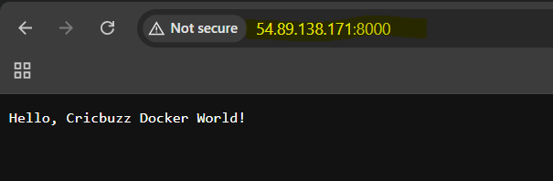
5. Configure to Save the Logs in the location /var/log/cb.log

Configure to save logs in /var/log/cb.log
Relevant Lines:
sudo touch /var/log/cb.log
sudo chmod 666 /var/log/cb.log
Creates the log file with world-writable permissions.
6. Write the Logrotate configuration for the above file

Write logrotate configuration for /var/log/cb.log
Relevant Lines:
cat <<'EOF' | sudo tee /etc/logrotate.d/cb > /dev/null
/var/log/cb.log {
daily
rotate 7
compress
missingok
notifempty
create 0644 root root
}
EOF
Rotates the log daily, keeps 7 compressed backups, and ensures safe creation.
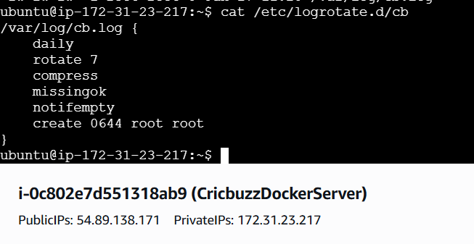 END

